San Diego California
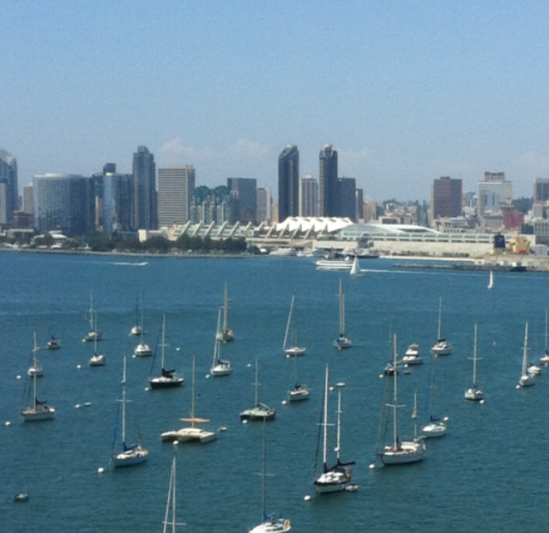 Coronado Bay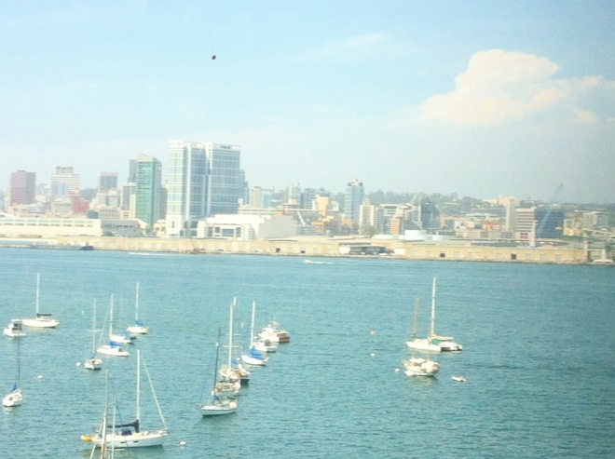
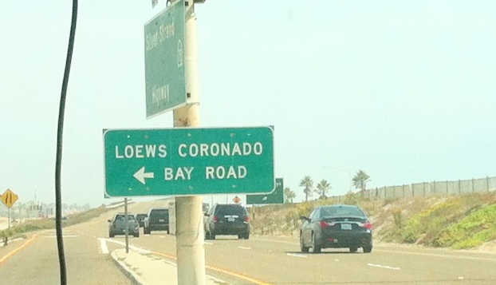
Sign to get to the hotel
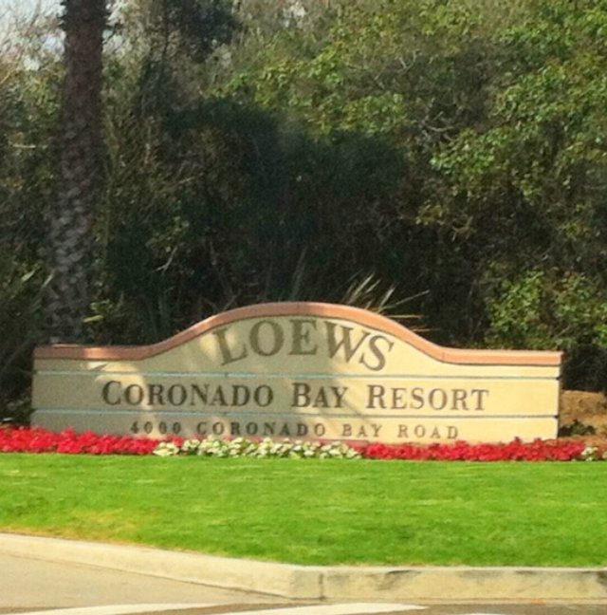Hotel welcoming sign
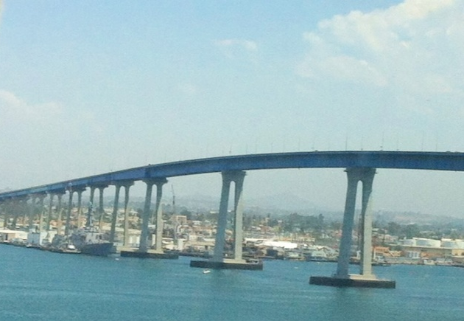The Bridge we went over every day to go into San Diego
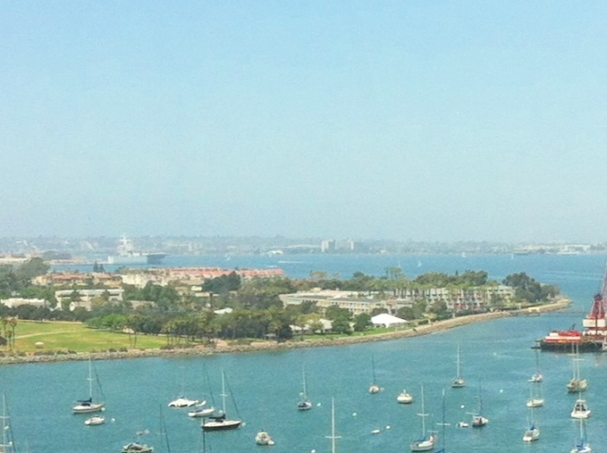The view of Coronado from the top of the bridge

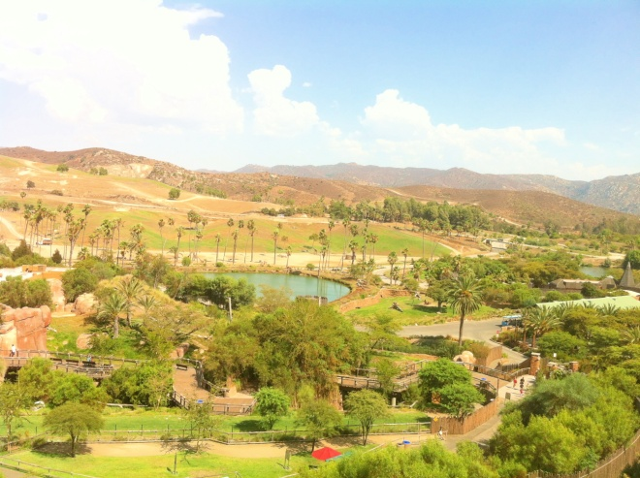
The safari part of San Diego Zoo
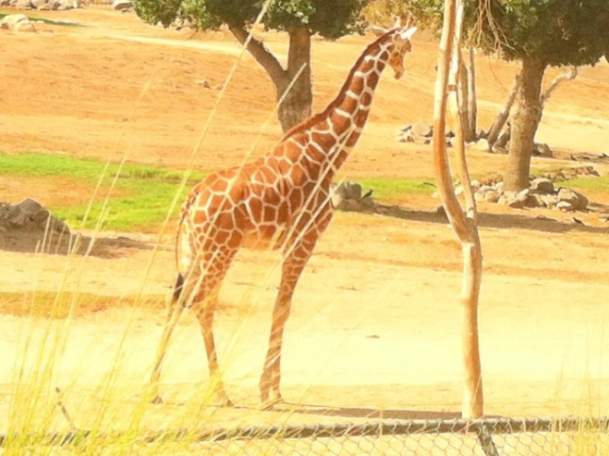A Giraffe during the safari
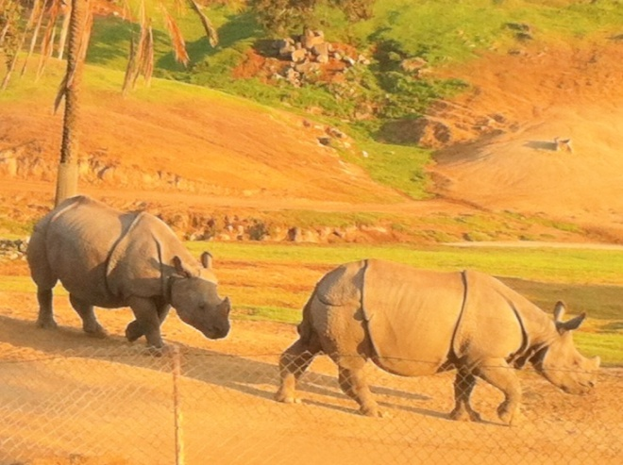 Baby Rhino and mother during the safari

Page one and two includes all photos that I took myself

My Business Card’s Logo
Sunflower- photo credit to Ray Dumas
http://www.flickr.com/photos/rtdphotography/2920439454/

http://commons.wikimedia.org/wiki/File:Hippopotamus_in_San_Diego_Zoo.jpg
photo of hippo at San Diego zoo
photo credit to wiki commons

http://commons.wikimedia.org/wiki/File:Tiger_in_san_diego_zoo_6.jpg
photo of tiger at San Diego Zoo
photo credit to wiki commons

http://commons.wikimedia.org/wiki/File:African_bush_elephant_in_San_Diego_Zoo.jpg
photo of elephant at Sam Diego Zoo
photo credit to wiki commons

http://de.wikipedia.org/wiki/San_Diego_Coronado_Bay_Bridge
photo of San Diego Coronado Bay Bridge
photo credit to wiki commons

http://www.tripadvisor.com/Hotel_Review-g32250-d76611-Reviews-Loews_Coronado_Bay_Resort-Coronado_California.html
inside the Lowes Coronado Bay Resort
photo credit to trip advisor

http://jessicagottlieb.com/2012/02/loews-coronado-bay-review-san-diego-area-hotel/
photo of sky shot of Coronado Bay
photo credit to Jessica Gottlieb

http://www.oyster.com/san-diego/hotels/loews-coronado-bay-resort-and-spa/
ocean view at the resort from the deck
photo credit to oyster.com

http://www.worldfromtheweb.com/Parks/SanDiego/SanDiego.html
city shot
photo credit to world from the web

http://www.flickr.com/photos/mrsmaxspix/4663425799/
hard rock café in San Diego
photo credit to lori05871 on Flicker

girls with facepaint
photo credit to wiki commons
http://commons.wikimedia.org/wiki/File:Face_paint_girls.jpg

Boy in pool
Photo credit to Yatmandu on Flikr
https://www.flickr.com/photos/yatmandu/2098931732/

couple out to eat
photo credit to Think Healthy Diet
http://www.thinkhealthydiet.com/what-are-some-ways-to-dine-out-while-keeping-health-in-mind/

tiger cub
photo credit to Auburn Alumni Association on flikr
https://www.flickr.com/photos/auburnalumniassociation/7986457901/in/photostream/

Auburn Alumni Association

